
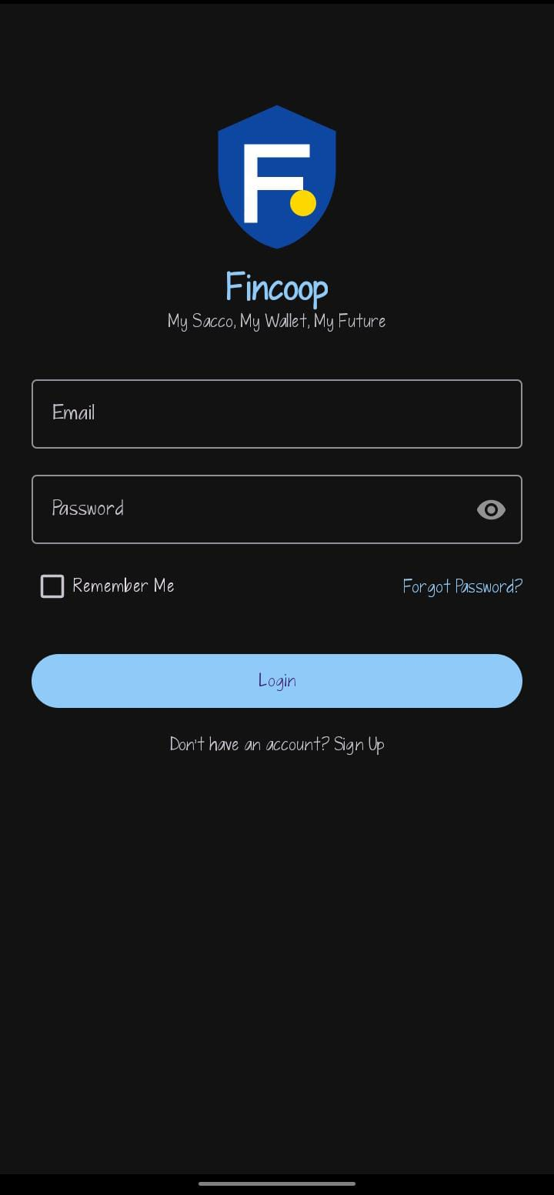
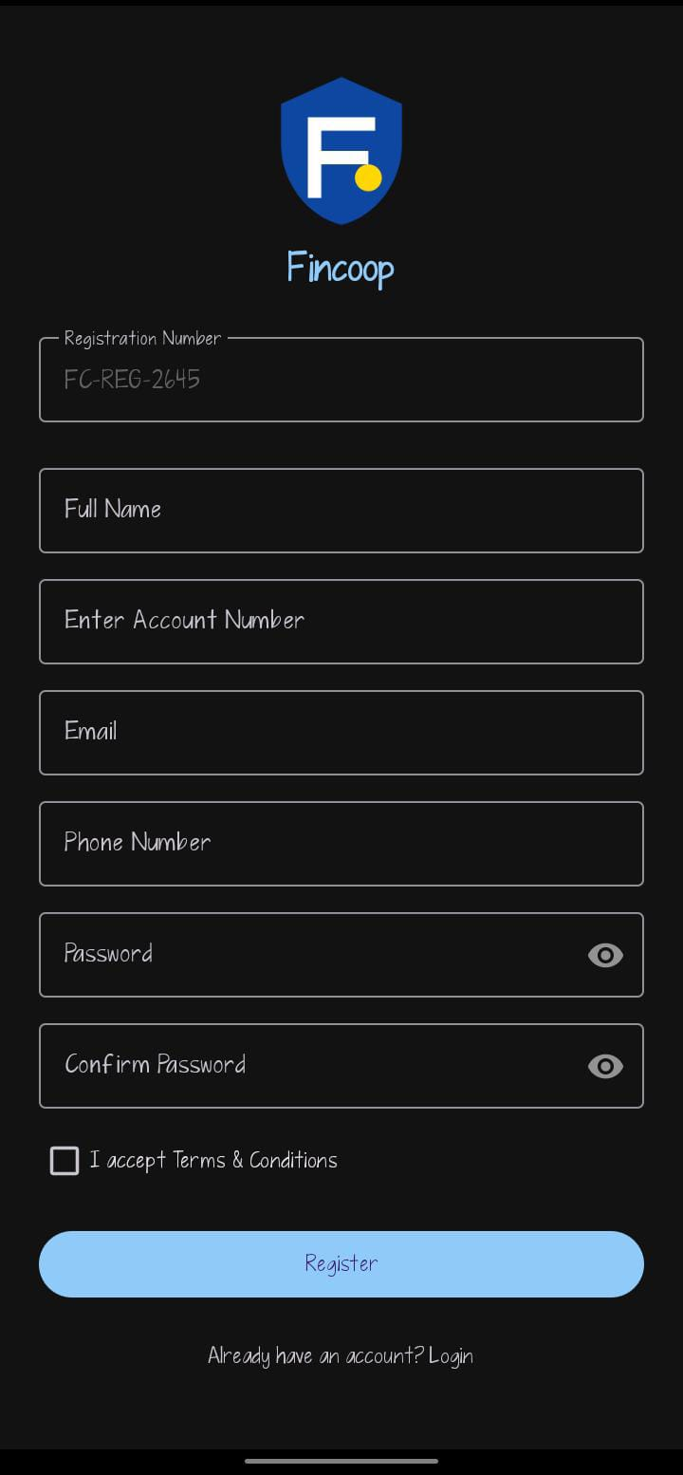

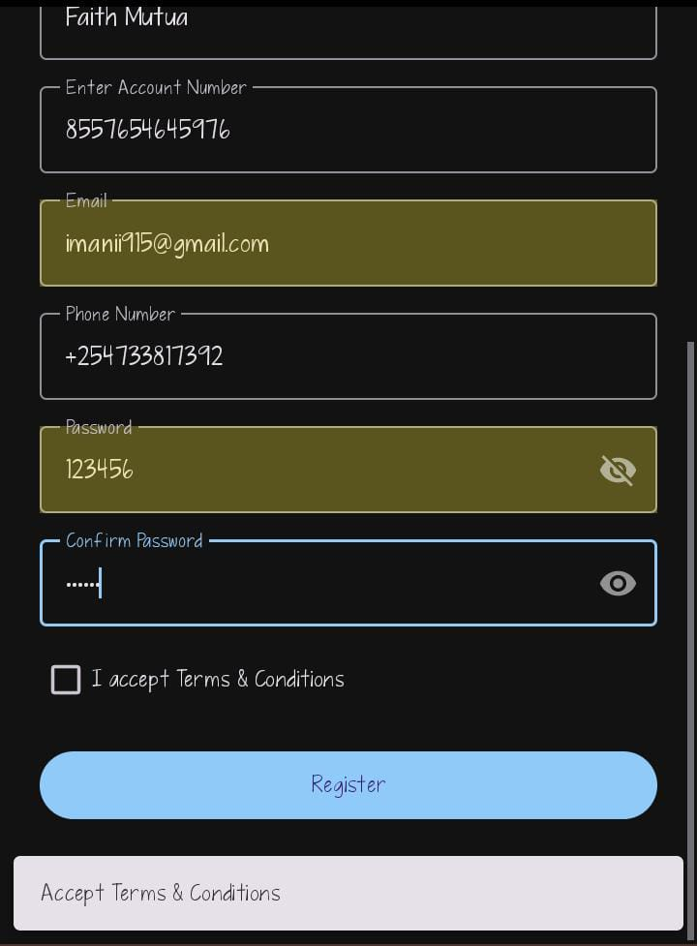
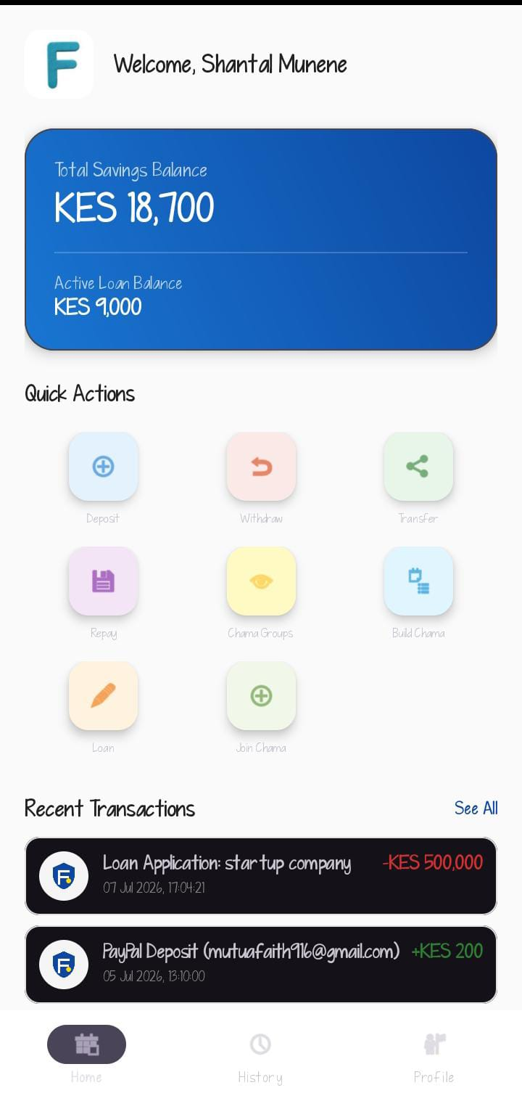
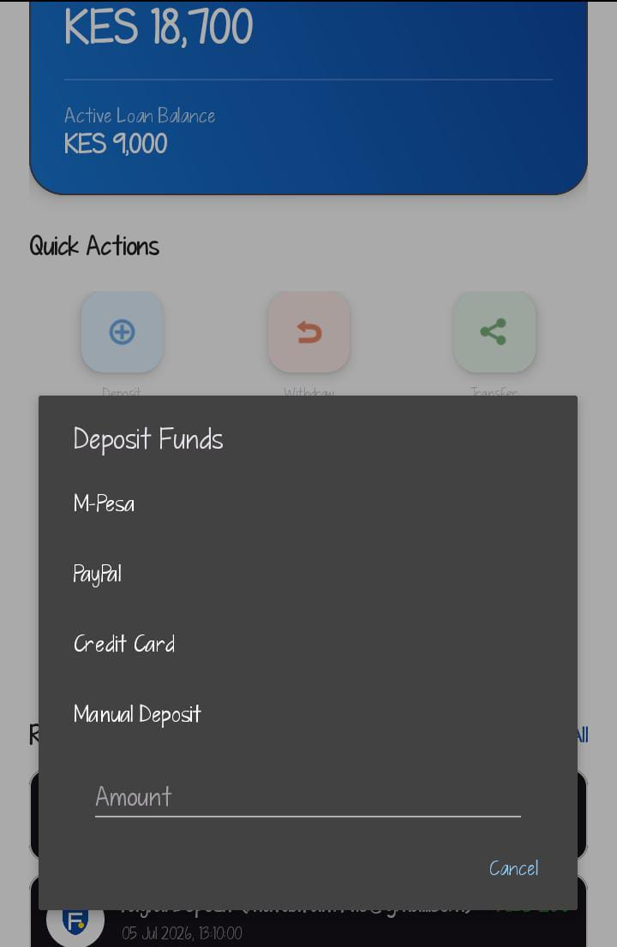
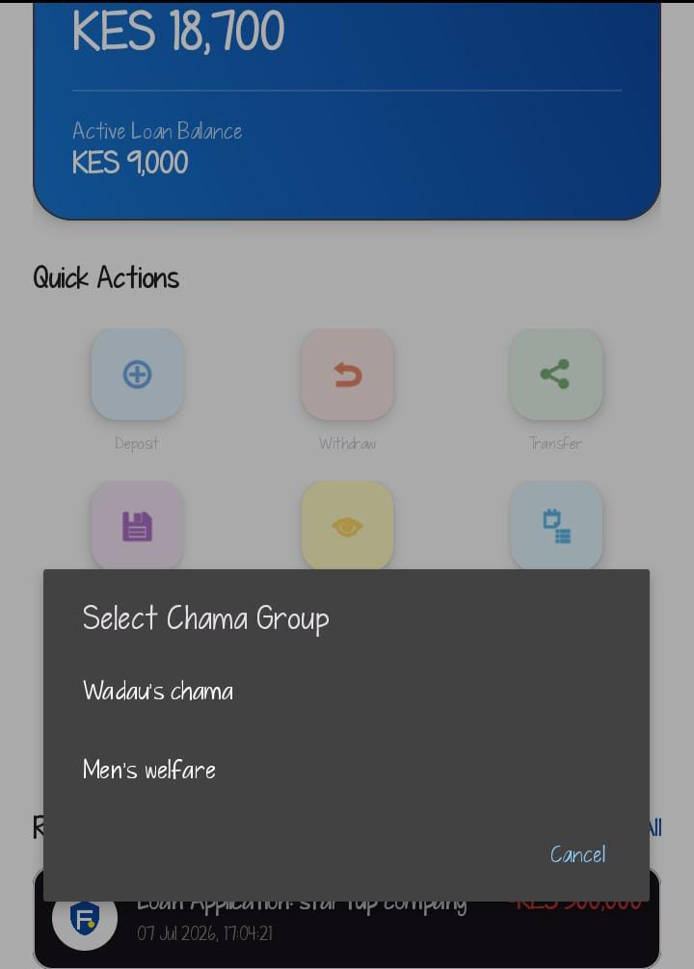
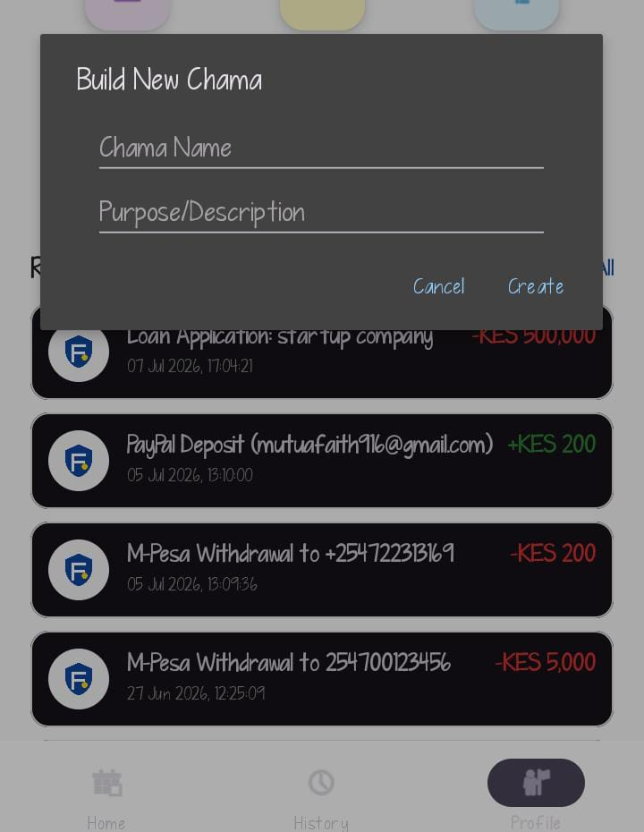

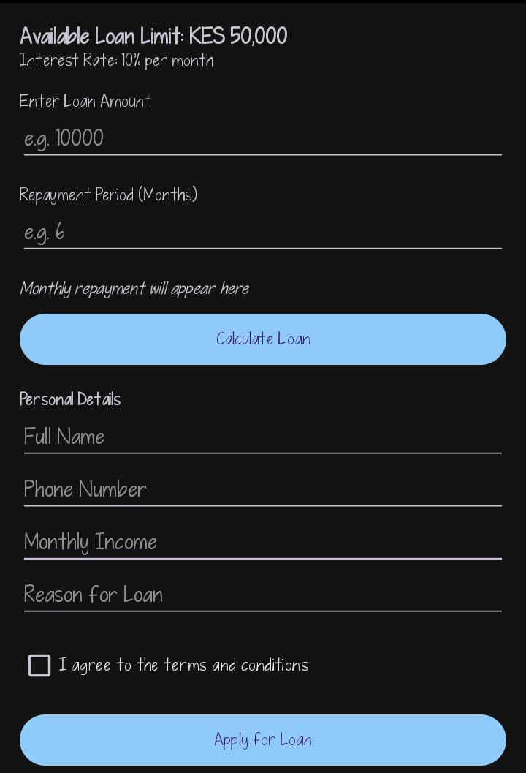
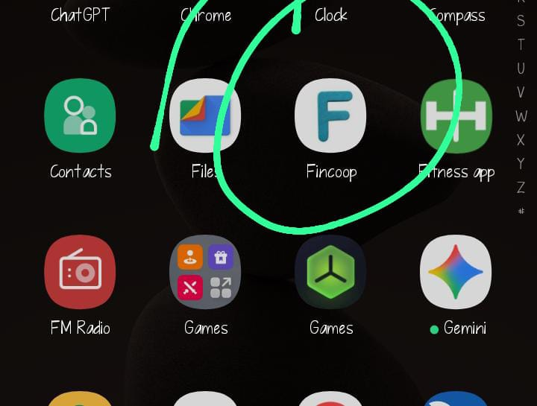

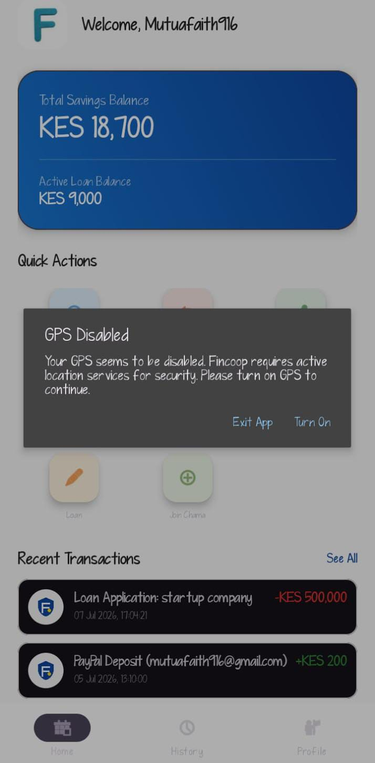
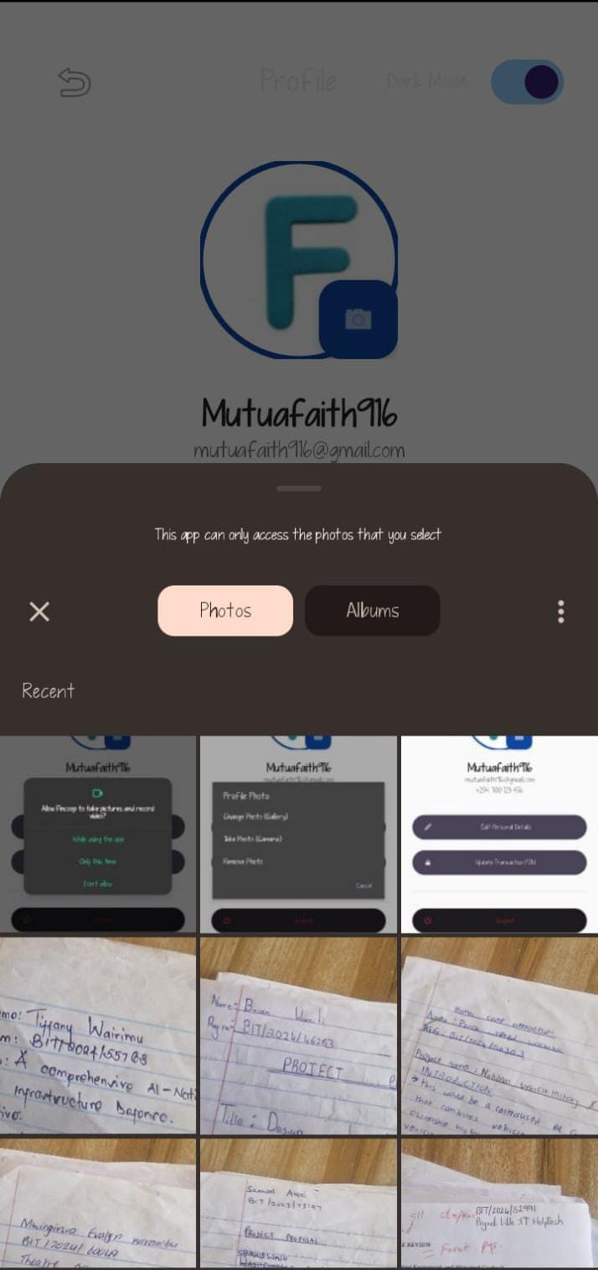
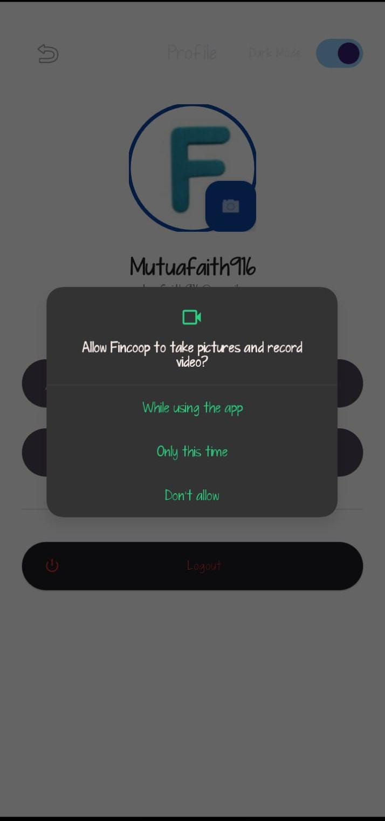
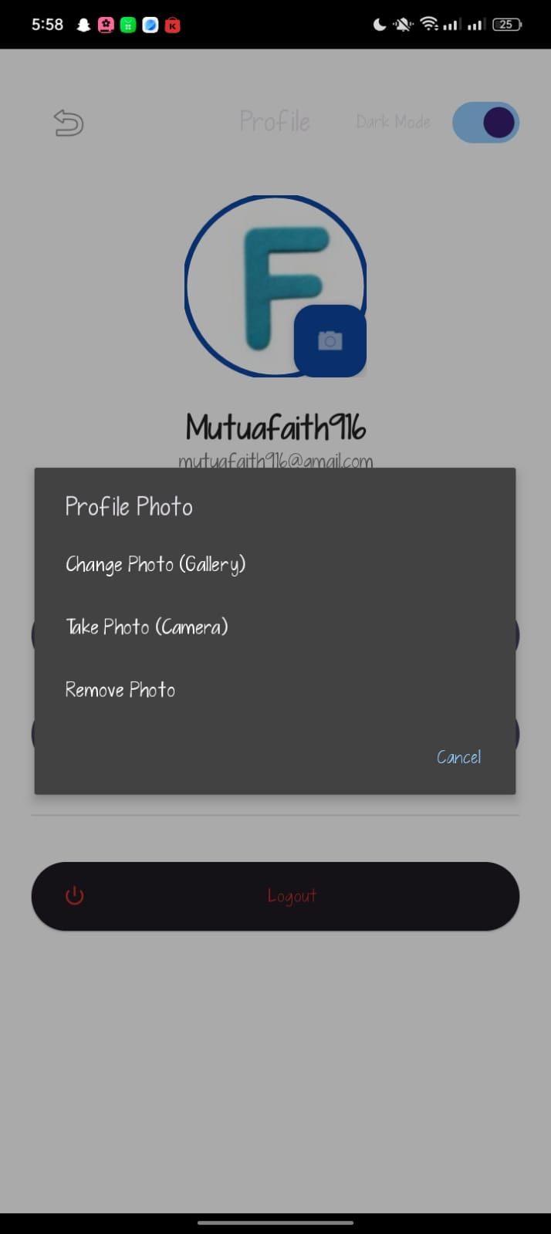
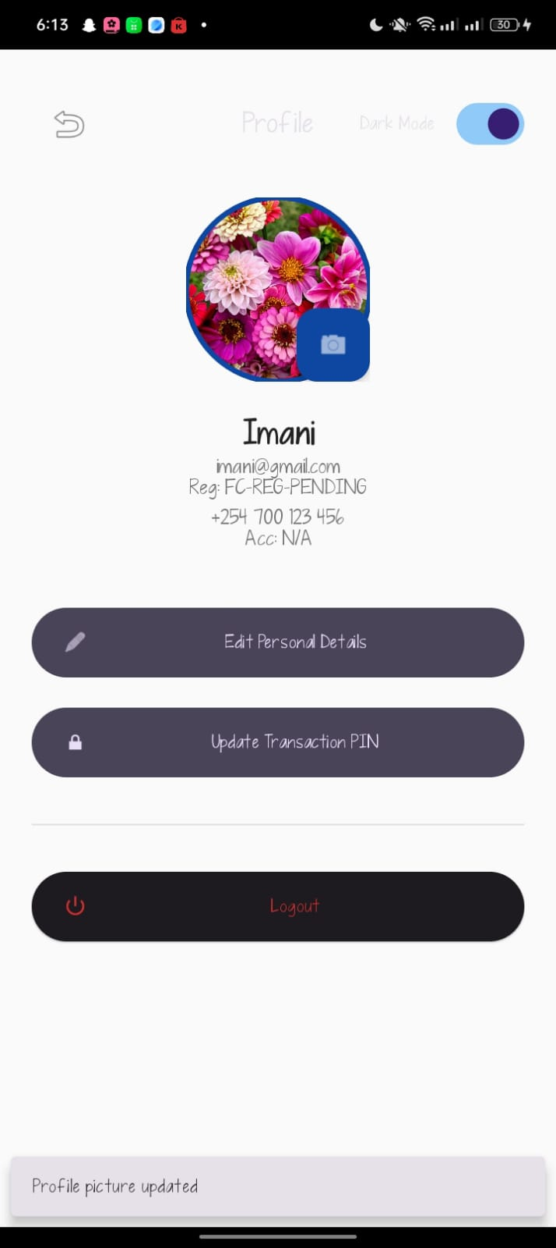
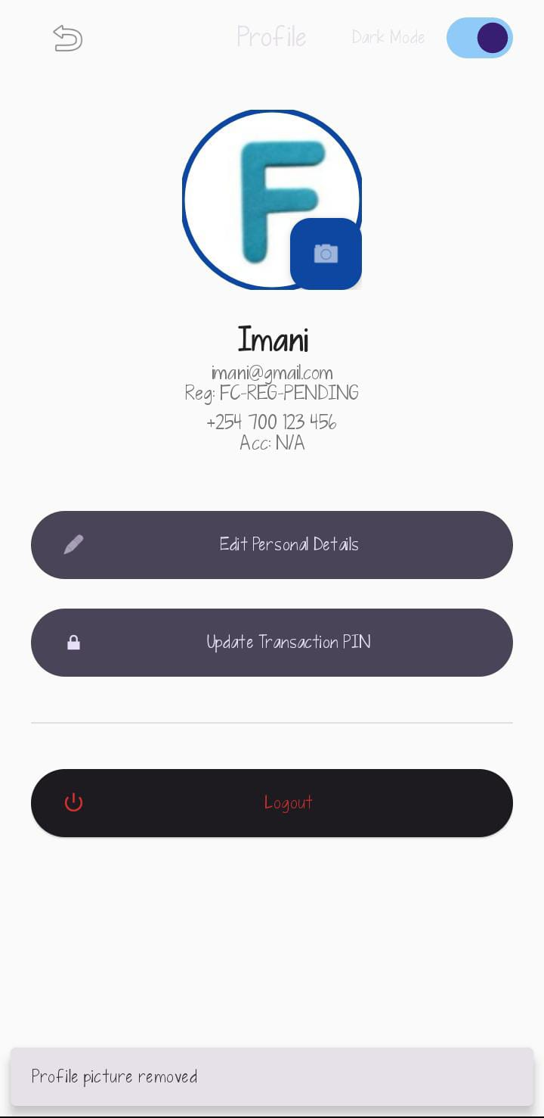
Personal reflection
During Week 10 and 11 ,I integrated all the major features of my FinCoop application, including the login, dashboard, loan application, transaction history, and camera/GPS functions. I tested each feature, fixed errors, improved navigation, and ensured data was stored correctly. This process helped me understand the importance of integrating and testing all application components to create a reliable and user-friendly mobile application . During Week 11, I prepared my FinCoop application for deployment by adding a professional app icon and splash screen, performing final testing, and capturing screenshots of the key features. I also ensured the application was stable, easy to use, and ready for presentation. This experience helped me understand the final stages of mobile app development and the importance of delivering a polished, professional application.
FinCoop Mobile Application User Guide

1. Introduction
Welcome to FinCoop, a mobile financial management application designed to help users manage savings, loans, transactions, and cooperative financial services conveniently from their smartphones. This guide explains how to use the application's main features.
2. System Requirements
- Android 8.0
- Stable internet connection
- Registered FinCoop account
- Valid email address and phone number
3. Getting Started
Step 1: Install the Application
Download and install the FinCoop application on your Android device.

Step 2: Create an Account
1. Open the app.
2. Tap Sign Up.
3. Enter your full name, email address, phone number, and password.
4. Confirm your password.
5. Tap Create Account.
Step 3: Log In
1. Open the app.
2. Enter your email and password.
3. Tap Login.
If you forget your password, use the Forgot Password option to reset it.
4. Home Dashboard
After logging in, the dashboard displays:
- Account balance
- Total savings
- Outstanding loans
- Quick action buttons
- Recent transactions
- Notifications

5. Savings
To manage savings:
1. Open the Savings section.
2. View your current savings balance.
3. Deposit or withdraw funds (where applicable).
4. Monitor your savings history.
6. Loans
The Loans section allows users to:
- Apply for a loan.
- View loan eligibility.
- Check loan status.
- View repayment schedule.
- Monitor remaining balance.
7. Transaction History
The transaction history screen enables users to:
- View all completed transactions.
- Filter transactions by date or type.
- Review transaction details.
- Monitor account activity.
8. Watchlist
The Watchlist feature allows users to save important financial products or opportunities for future reference. Users can add or remove items at any time.
9. Option History
The Option History screen keeps a record of user actions and selected financial options, making it easy to review previous activities.
10. Notifications
Users receive notifications for:
- Successful transactions
- Loan approvals
- Payment reminders
- Savings updates
- Important account announcements
11. Profile Management
Users can:
- Edit personal information.
- Change their password.
- Update contact details.
- Upload or change a profile picture.
- Log out securely.
12. Security Features
FinCoop protects user information by:
- Secure login authentication.
- Password encryption.
- Secure database storage.
- Session management.
- User access control.
13. Troubleshooting
Unable to log in
- Verify your email and password.
- Check your internet connection.
- Reset your password if necessary.
Transactions not loading
- Refresh the page.
- Check your internet connection.
- Log in again.

Application crashes
- Restart the application.
- Update to the latest version.
- Reinstall the application if the issue persists.
14. Frequently Asked Questions (FAQs)
Q: Can I access my account on multiple devices?
Yes, provided you log in using your registered credentials.
Q: Is my financial information secure?
Yes. FinCoop uses secure authentication and encrypted storage to protect user data.
Q: Can I view previous transactions?
Yes. All completed transactions are available in the Transaction History section
15. Conclusion
FinCoop provides a secure and user-friendly platform for managing savings, loans, and financial transactions. Users are encouraged to keep their login credentials confidential and regularly update the application to benefit from the latest features and security improvements.

